**19CSE301**

**COMPUTER NETWORKS**

**PEER-TO-PEER FILE TRANSFER SYSTEM**

|  |  |
| --- | --- |
| **NAME** | **ROLL NUMBER** |
| 1. DHORA SATHYAMURTHY | CB.EN.U4CSE22203 |
| D.L PRASAD REDDY | CB.EN.U4CSE22212 |
| N. SAI KUMAR | CB.EN.U4CSE22239 |
| V.HEMANTH | CB.EN.U4CSE22254 |

**PROJECT TITLE:**

Peer-to-Peer File Transfer System.

**ABSTRACT:**

The Peer-to-Peer (P2P) File Transfer System allows users to share files directly with each other without needing a central server. It offers an efficient and scalable way to share files by connecting users directly and letting them share resources. The P2P model ensures that files are distributed reliably, can handle failures better, and makes good use of resources by spreading the workload across everyone in the network.

**2. PROJECT DESCRIPTION:**

The Peer-to-Peer File Transfer System is a network that lets users share files directly with each other without the need of central server. It uses P2P protocols to connect users so they can exchange files quickly and securely. This system is built to handle large amounts of data, be reliable even if some connections fail, and keep the shared files safe and intact.

The system is composed of the following key modules:

1.Connection Management Module:

* Protocols: TCP, UDP
* Description: It sets up and manages connections between users. TCP is used to make sure that files are transferred reliably and in the correct order. UDP is used for quickly finding other users and handling tasks that don't need to be as reliable.

2. File Sharing and Distribution Module:

* Protocols: TCP, BitTorrent
* Description: It manages the actual file transfers between users. The BitTorrent protocol breaks large files into smaller pieces, allowing them to be downloaded from several users at the same time, which makes the process faster and more efficient

3. Peer Discovery Module:

* Protocols: UDP, DHT (Distributed Hash Table)
* Description: It helps users find others in the network. UDP is used to send messages to everyone, and DHT offers a way to find files or users without relying on a central server.

4. Security Management Module:

* Protocols: TLS/SSL, TCP
* Description: It keeps communication between users secure by encrypting data transfers using TLS/SSL over TCP. This part also takes care of verifying users and making sure the data hasn't been tampered with.

5. File Indexing and Search Module:

* Protocols: HTTP/HTTPS, DHT
* Description: It lets users search for files across the network. DHT is used to organize file information without needing a central server, and HTTP/HTTPS can provide an easy-to-use search interface.

6. Download and Upload Management Module:

* Protocols: TCP, BitTorrent
* Description: It manages the downloading and uploading of files. This part keeps track of download and upload progress, retries if something goes wrong, and makes sure the data is fully and correctly transferred.

7. Fault Tolerance and Recovery Module:

* Protocols: TCP, BitTorrent, SFTP
* Description: It makes sure the system can recover if file transfers get interrupted. If a user disconnects, the system lets other users continue the transfer using BitTorrent's backup features. SFTP is used to securely resume interrupted file transfers.

8. Network Monitoring and Reporting Module:

* Protocols: SNMP (UDP), HTTP/HTTPS
* Description: It tracks how well the network is performing and provides reports on file transfer statistics. SNMP can gather real-time data on the network's health, and HTTP/HTTPS can display this information through a web interface.

**Topology and Architecture**:

* Network Topology: The system uses a distributed network setup where each node (or peer) acts as both a client and a server. Nodes can connect to many other nodes at the same time, creating a mesh network that improves fault tolerance and spreads the load evenly.
* Architecture: The system combines centralized indexing (to help find peers) with decentralized file sharing. Nodes have a partial view of the network and use protocols like DHT to find resources.

**Environment Setup:**

* Nodes: Each node in the network is set up with the necessary software to share files, including support for protocols like TCP, UDP, and BitTorrent. Nodes can handle both control and data connections, making file management and transfer efficient.
* Fault Tolerance: The system includes features to handle faults, such as data redundancy and automatic recovery from failed connections. If a connection fails during a file transfer, the system can resume the download from other available peers, ensuring the file is transferred completely and correctly

**OSI LAYER PROTOCOLS:**

* Physical Layer (Layer 1): Physical medium (Copper/Fiber Optic Cables, Wireless)
* Data Link Layer (Layer 2): Ethernet, Wi-Fi
* Network Layer (Layer 3): IP
* Transport Layer (Layer 4): TCP, UDP
* Session Layer (Layer 5): Managed by TCP and TLS/SSL
* Presentation Layer (Layer 6): Handled by TLS/SSL and HTTPS for encryption and data formatting.
* Application Layer (Layer 7): BitTorrent, HTTP/HTTPS, SFTP, SNMP, TLS/SSL

**3**.**DESIGN REQUIREMENT OF TRANSPORT SERVICE:**

|  |  |  |
| --- | --- | --- |
| **ASPECT** | **PURPOSE** | **PROTOCOLS** |
| **RELAIBLE DATA TRANSFER** | Ensures that files are delivered accurately and in sequence | TCP, SFTP, BitTorrent |
| **TIMING** | Critical for ensuring efficient file discovery, connection establishment, and transfer completion | TCP/UDP, BitTorrent, SNMP(UDP) |
| **THROUGHPUT** | Necessary for handling high volumes of file data without delays | TCP, BitTorrent |
| **SECURITY** | Protects against unauthorized access and data breaches, ensuring secure file transfers | TLS/SSL, SFTP |

**4. TRANSFER PROTOCOL AND CONNECTIONS REQUIRED FOR EACH PROTOCOL:**

|  |  |  |
| --- | --- | --- |
| **MODULE NAME** | **PROTOCOLS** | **NUMBER OF CONNECTIONS REQUIRED** |
| **Connection Management Module** | TCP, UDP | 2+(TCP), 2+(UDP) |
| **File Sharing and Distribution Module** | TCP, BitTorrent | 2+(TCP), Multiple(BitTorrent) |
| **Peer Discovery Module** | UDP, DHT | 2+(UDP) |
| **Security Management Module** | TLS/SSL, TCP | 2+(TCP), 2(TLS/SSL) |
| **File Indexing and Search Module** | HTTP/HTTPS, DHT | 2+(HTTP/HTTPS), 2+(DHT) |
| **Download and Upload Management Module** | TCP, BitTorrent | 2+(TCP), Multiple(BitTorrent) |
| **Fault Tolerance and Recovery Module** | TCP, BitTorrent, SFTP | 2+(TCP), Multiple(BitTorrent), 2+(SFTP) |

**BLOCK DIAGRAM:**

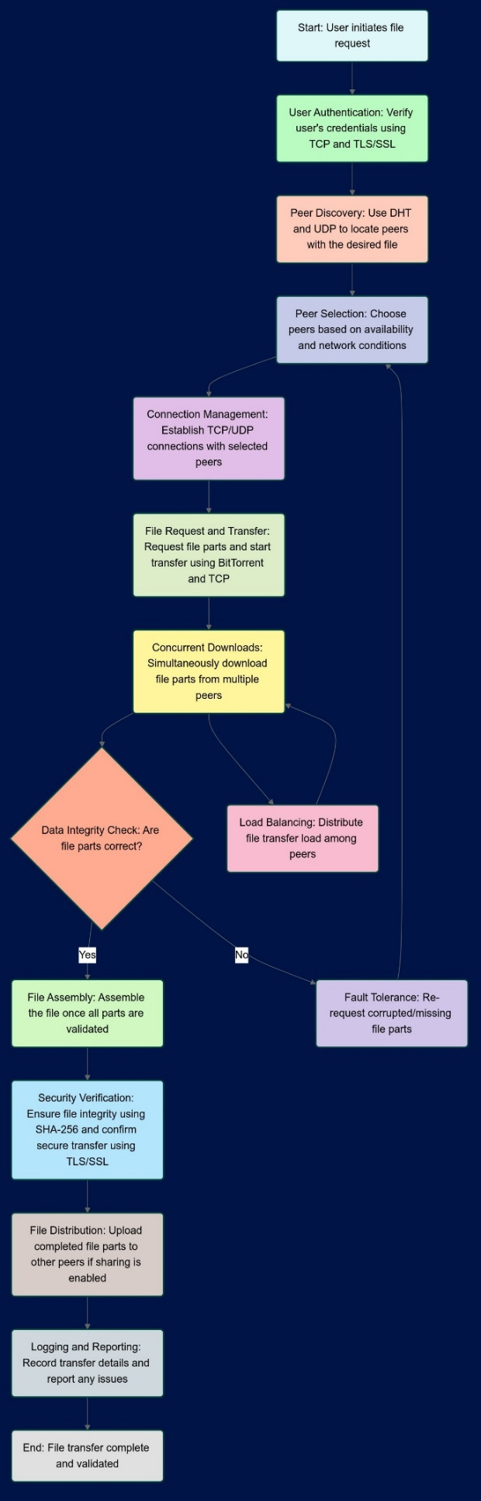

Case 1: Successful Transmission:

The file is successfully transferred between two nodes using the FTP protocol. Even if the file is broken down into fragments, all parts are correctly received and reassembled by the receiving node.

Case 2: Fault Tolerance:

During the file transfer, one of the nodes disconnects. The system detects the failure and automatically re-routes the remaining fragments to be downloaded from other available nodes, ensuring the complete file is received without corruption.

**5. WORK PLAN FOR EVALUATIONS:**

**PART 1:**

The initial implementation, focusing on the system's ability to establish connections, discover peers, and securely transfer files.

**PART 2:**

Final evaluation of the complete system, focusing on its performance, fault tolerance, and robustness in various scenarios. Present the system to peers or evaluators, demonstrating its key features.

**6. CONCLUSION:**

The Peer-to-Peer (P2P) File Transfer System is a strong and decentralized way to share files. It uses protocols like TCP, UDP, BitTorrent, and TLS/SSL to make file transfers efficient, secure, and reliable. Its flexible design supports scalable and effective file sharing across a distributed network, making it a great tool for today’s file distribution needs.